100-1
August 3, 2013
EDUCATION SERIES

About Learners and Learning

Birth______________________________________________________________Death
Road of Life

Learner – every person is a learner on the road of life

Life Stages:
- Early childhood
- Childhood
- Young adult/youth
- Adult
- Mature adult
- Senior

Life roles*
- Individual
- Learner
- Producer
- Citizen
- Consumer
- Family member
*Oregon Educational Act, 1990

To learn is to change behaviour,
- Attitudes –affective - act in a way that is different from before
- Skills – psychomotor - able to perform existing skills better or to perform new skills
- Knowledge – cognitive - has additional or new knowledge

What we learn – we select

Why learn – Insert Maslow’s needsto satisfy a need
To gain the skills, knowledge and attitudes required to cope with,
contribute to and enjoy life

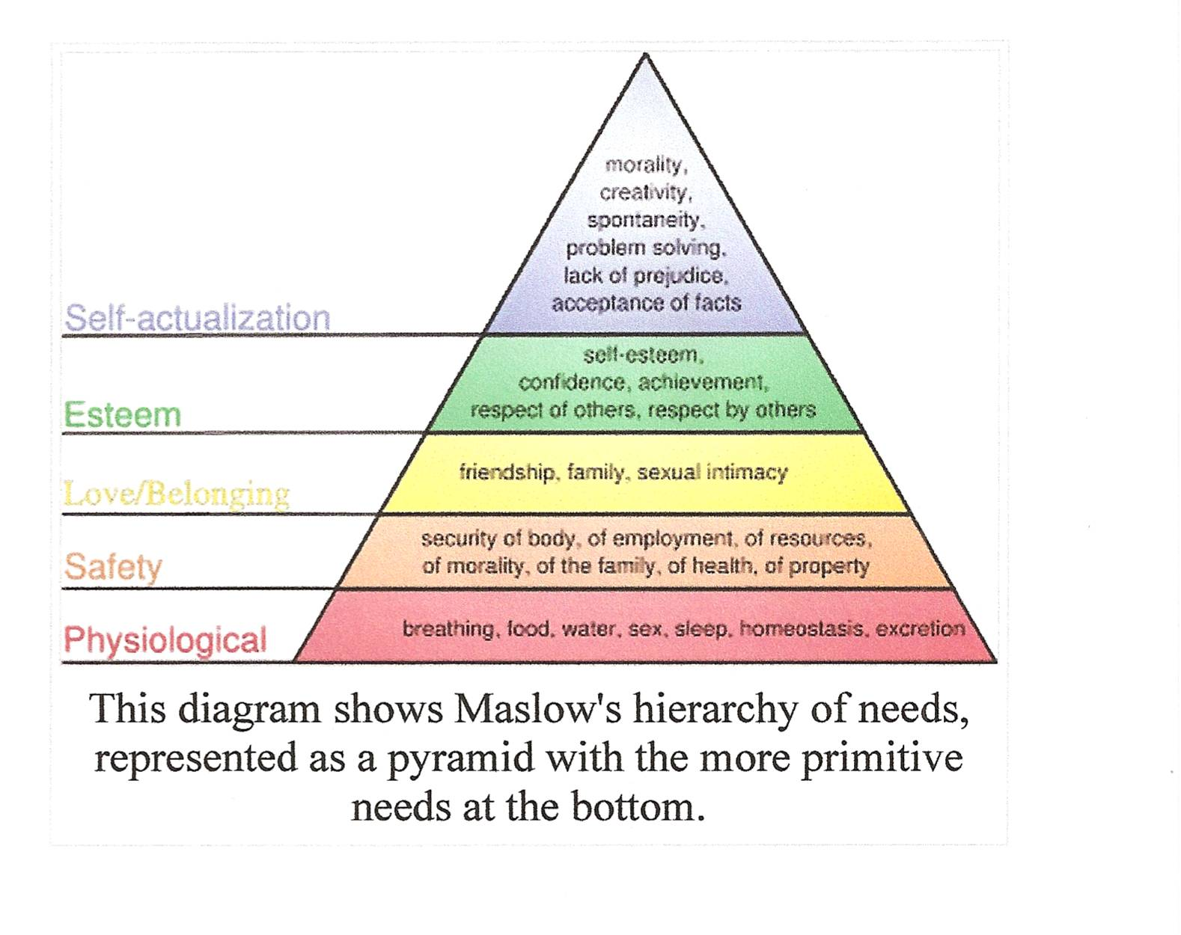

Importance:
- Must know
- Should know
- Nice to know

Characteristics
- Own action although may occur in group setting
- Own decision
- Own pace
- Own style
- Own reasons

Levels -Bloom's Taxonomy - visual
- Evaluation
- Synthesis
- Analysis
- Application
- Comprehension
- Understanding!
- Awareness

Changes arising from learning are:
- Definable
- Observable
- Demonstrable
- Measurable

Conditions for learning:
- Motivation
- Engagement
- Readiness
- Opportunity

Support for learning:
- Information
- Guidance
- Encouragement
- Demonstration
- Model/mentor
- Recognition

Education - all the learning that has a continuing formative effect on a person

